Terraform Challenge

- Create an EC2 Instance on AWS Cloud using the below-mentioned ubuntu AMI and instance_type. Or, (You can use of your choice as well) ami = "ami-0461b1436c9b3c1a3" instance_type = "t2.micro"
- Install a web server on the same EC2 Instance. The web server should listen on port 8080.
- Create a Docker-compose file for the project:https://github.com/betawins/cricbuzz-docker-helloworld.gitand point it to port 8000.
- Make the web server point to the above service so that 8080 returns the response from the Docker service.
- Configure to Save the Logs in the location /var/log/cb.log
- Write the Log rotate configuration for the above file

Step 1: Configure Terraform Provider
The first step is to define the Terraform and AWS provider configuration. terraform { required_providers { aws = {
source = "hashicorp/aws" version = "~> 6.0"
}
}
}

provider "aws" { region = "us-east-1"
}
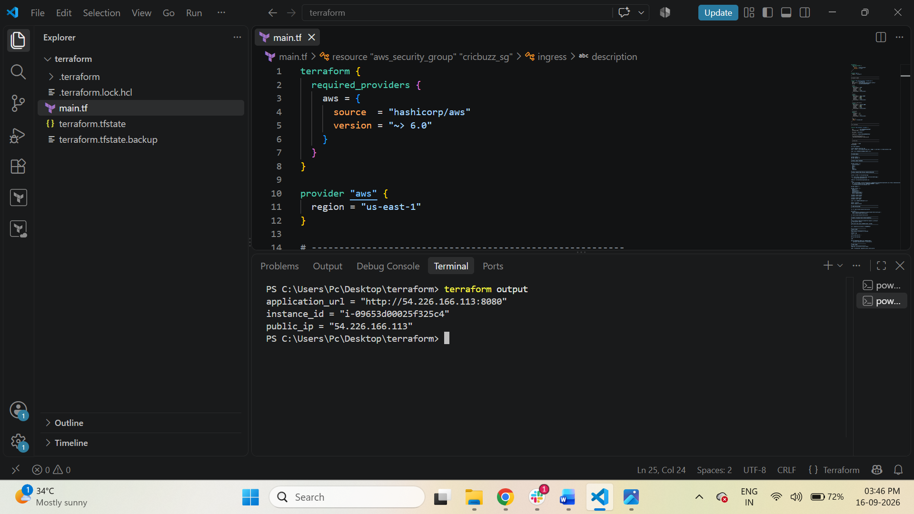
Explanation
- terraform → Defines Terraform configuration.
- required_providers → Specifies which providers Terraform needs.
- aws → AWS provider.
- hashicorp/aws → Official AWS provider from HashiCorp.
- ~> 6.0 → Uses AWS provider version 6.x.
- provider "aws" → Configures AWS.
- region = "us-east-1" → Resources are created in the US East (N. Virginia) region.

Step 2: Create Security Group
The script creates an AWS Security Group for the EC2 instance.
resource "aws_security_group" "cricbuzz_sg" {
The Security Group allows incoming traffic on:
Port Purpose
22 SSH
8080 Nginx
8000 Docker application
SSH – Port 22
ingress { description = "SSH" from_port = 22 to_port = 22 protocol = "tcp" cidr_blocks = ["0.0.0.0/0"]
}

This allows SSH connections to the EC2 instance.
Example: ssh -i devops.key ubuntu@<PUBLIC-IP>
For a production environment, SSH should preferably be restricted to a trusted IP rather than 0.0.0.0/0.
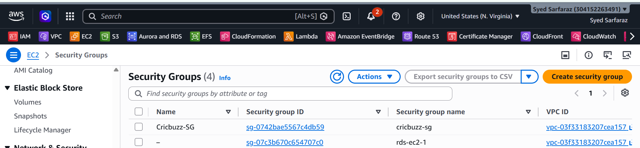

Step 3: Allow Nginx Port 8080
ingress { description = "Nginx 8080" from_port = 8080 to_port = 8080 protocol = "tcp" cidr_blocks = ["0.0.0.0/0"]
}
Port 8080 is opened because Nginx is configured to listen on port 8080.
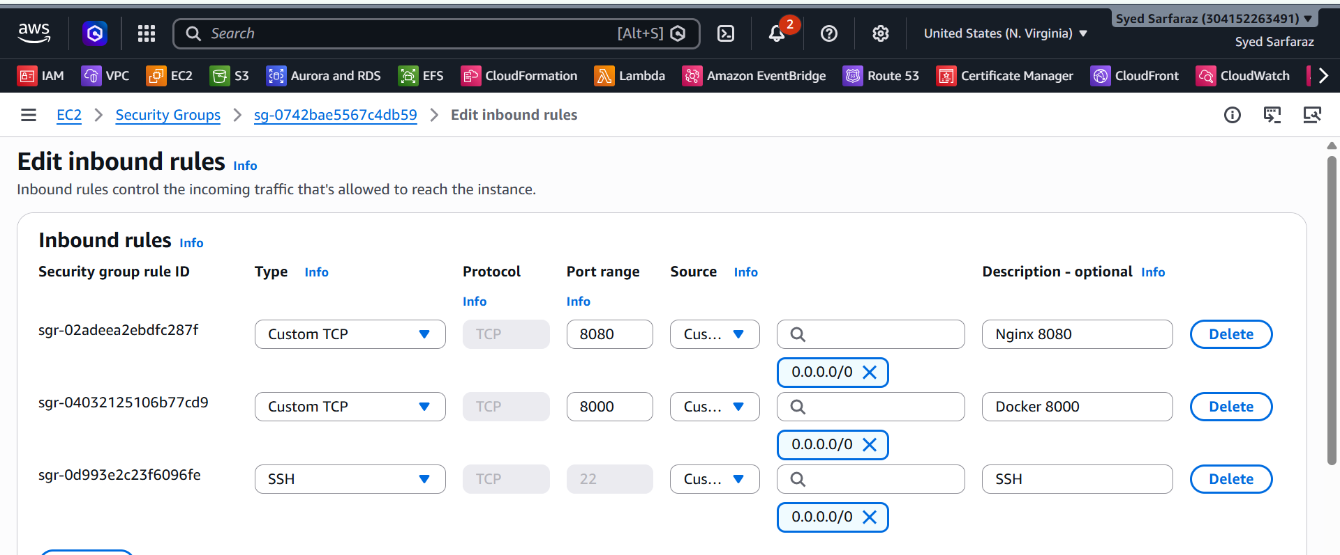
Users access the application using:
http://<EC2-PUBLIC-IP>:8080
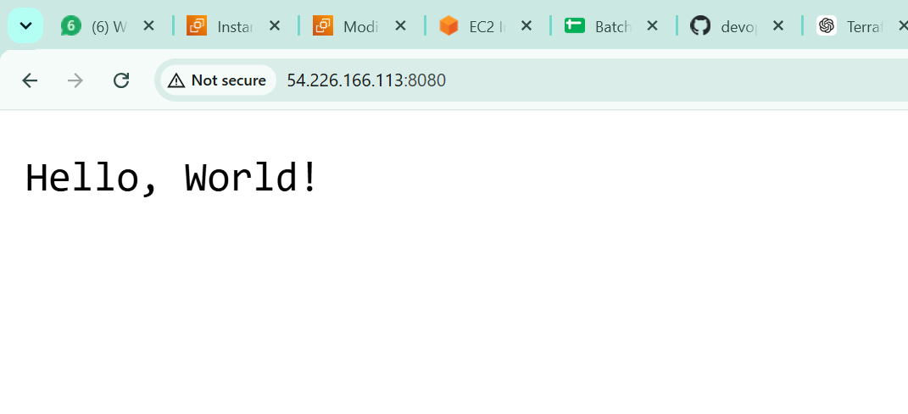

Step 4: Allow Docker Application Port 8000
ingress { description = "Docker 8000" from_port = 8000 to_port = 8000 protocol = "tcp" cidr_blocks = ["0.0.0.0/0"]
}
This allows traffic to port 8000.
However, in this architecture, the external user normally accesses Nginx on 8080, while Nginx forwards the request internally to Docker on port 8000.
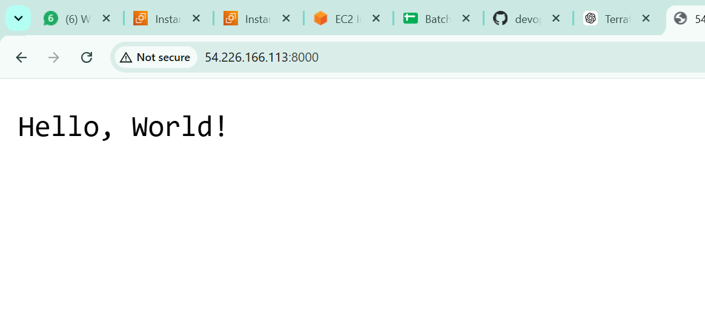

Step 5: Configure Outbound Traffic egress {
from_port = 0 to_port = 0 protocol = "-1" cidr_blocks = ["0.0.0.0/0"]
}
This allows the EC2 instance to make outbound connections to the internet.
This is required for things such as:
- apt-get update
- Installing packages
- Downloading Docker
- Cloning GitHub repository
- Downloading Go dependencies
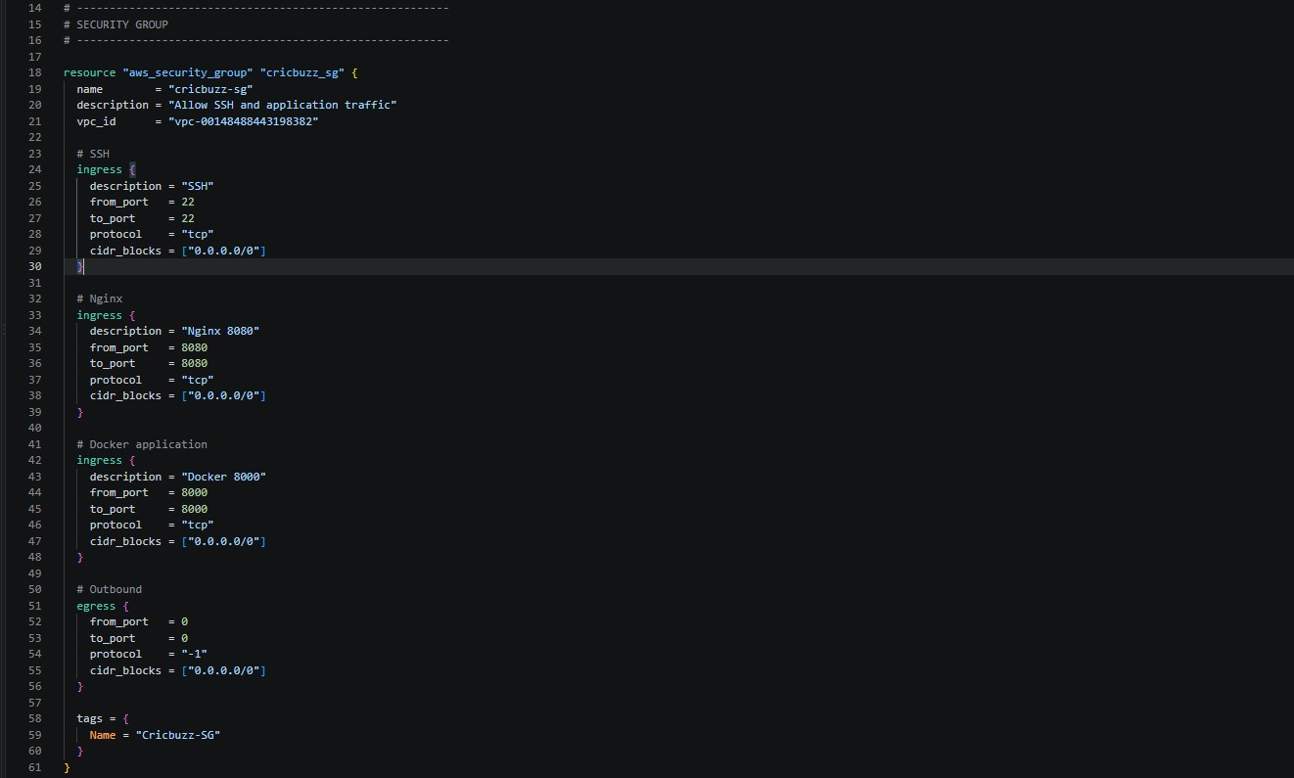
•

Pulling Docker images

Step 6: Create EC2 Instance

Terraform creates an EC2 instance using: resource "aws_instance" "cricbuzz" {
Important configuration:
ami = "ami-0b6d9d3d33ba97d99"
instance_type = "t3.micro"
key_name = "devops.key"
subnet_id = "subnet-09d53b9b035621be1"
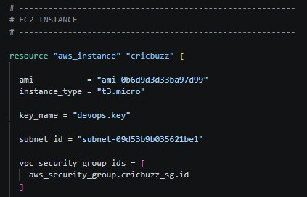
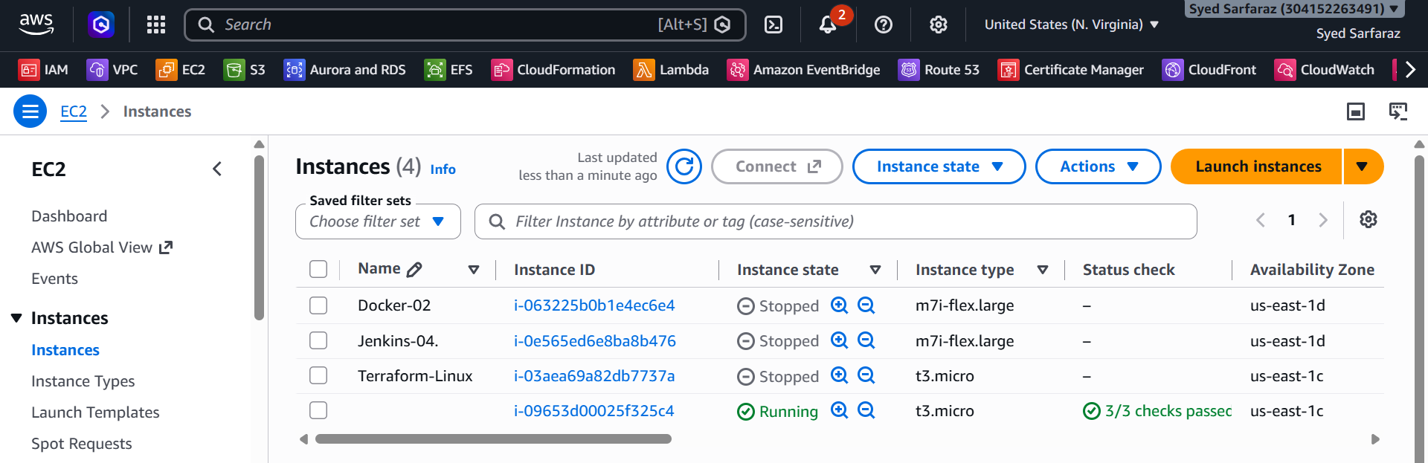
Explanation
- ami → Ubuntu machine image.
- instance_type → t3.micro.
- key_name → Existing EC2 key pair used for SSH.
- subnet_id → Subnet where EC2 is launched.

Step 7: Attach Security Group to EC2
vpc_security_group_ids = [ aws_security_group.cricbuzz_sg.id
]
This connects the Security Group created by Terraform to the EC2 instance.
So the EC2 instance receives the inbound/outbound rules defined earlier.
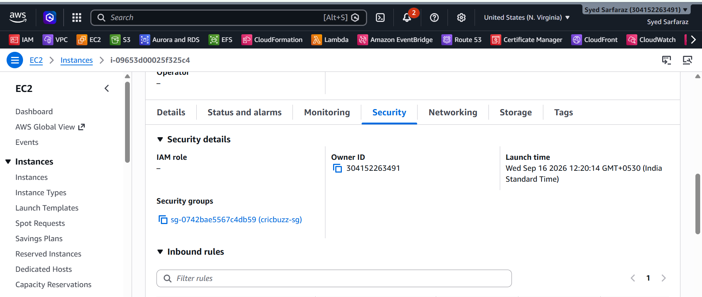

Step 8: Use User Data for Automatic Configuration
The most important part of the script is:
user_data = <<-EOF
The User Data script runs automatically when the EC2 instance is launched.
Instead of manually logging into the server and installing everything, Terraform automatically performs the setup.
The overall process is:
EC2 Created
↓
User Data Starts
↓
Update OS
↓
Install Packages
↓
Install Docker
↓
Install Nginx
↓
Clone Git Repository
↓
Create Dockerfile
↓
Create Docker Compose
↓
Build Docker Image
↓
Start Container
↓
Configure Nginx
↓
Configure Logrotate
↓
Run Tests

Step 9: Enable Error Handling and Logging
The script starts with:
set -euxo pipefail
This helps identify errors during the User Data execution.
The script also saves the bootstrap output: exec > >(tee -a /var/log/user-data.log | logger -t user-data -s 2>/dev/console) 2>&1
Therefore, if the deployment fails, we can check: cat /var/log/user-data.log
This is useful for troubleshooting EC2 bootstrap issues.
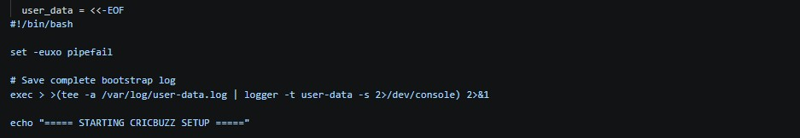

Step 10: Update Ubuntu

The script runs: apt-get update -y apt-get upgrade -y
Purpose apt-get update
→ Updates the package repository information. apt-get upgrade
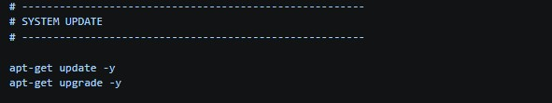
→ Upgrades installed packages to newer versions.

Step 11: Install Required Packages

The script installs: apt-get install -y \ ca-certificates \ curl \ gnupg \ git \ nginx \ logrotate
Packages
Package Purpose
ca-certificates SSL/TLS certificates
curl | Download/test URLs
gnupg | Verify package repository signatures
git | Clone application source code
nginx | Web server/reverse proxy
logrotate | Rotate application/server logs
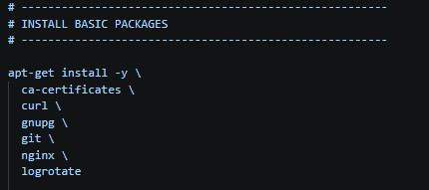
Step 12: Install Docker
The script creates the Docker keyring directory:
install -m 0755 -d /etc/apt/keyrings
Then downloads Docker's GPG key: curl -fsSL https://download.docker.com/linux/ubuntu/gpg \
-o /etc/apt/keyrings/docker.asc
Then it adds the official Docker repository.
After that:
apt-get update -y
The following Docker components are installed:
apt-get install -y \ docker-ce \ docker-ce-cli \ containerd.io \ docker-buildx-plugin \ docker-compose-plugin
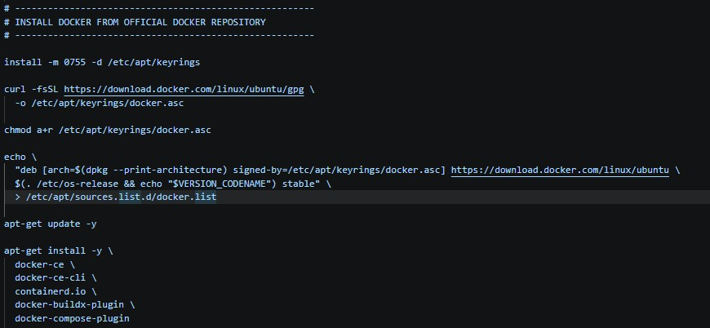
Components
- docker-ce → Docker Engine
- docker-ce-cli → Docker command-line interface
- containerd.io → Container runtime
- docker-buildx-plugin → Advanced Docker image building
- docker-compose-plugin → Docker Compose

Step 13: Start and Enable Docker systemctl enable docker systemctl start docker Meaning
enable
→ Starts Docker automatically when the server boots.
start
→ Starts Docker immediately. The script verifies the installation:
docker --version
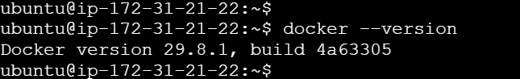

docker compose version
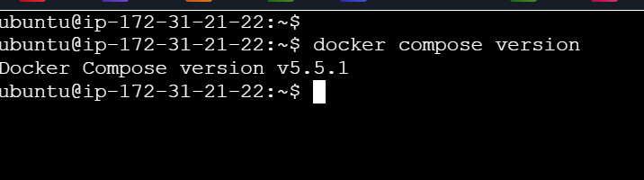

Step 14: Start Nginx
systemctl enable nginx systemctl start nginx Nginx is:
- Enabled at boot
- Started immediately
Later, Nginx will act as a reverse proxy in front of the Docker application.
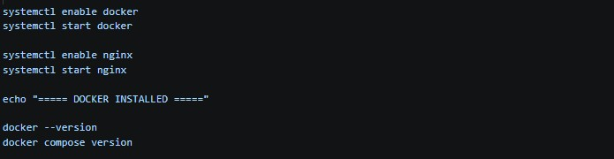

Step 15: Clone the Application Repository The script removes any previous application directory:
rm -rf /opt/cricbuzz-docker-hello-world
Then clones the GitHub repository:
git clone \ https://github.com/betawins/cricbuzz-docker-hello-world.git \
/opt/cricbuzz-docker-hello-world
The application is therefore stored at:
/opt/cricbuzz-docker-hello-world Then the script enters the directory:
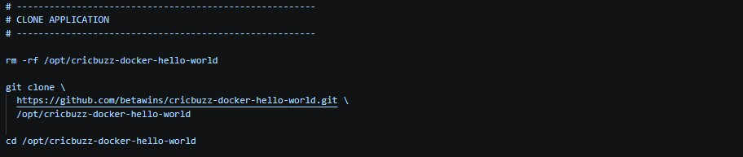
cd /opt/cricbuzz
-
docker
-
hello
-
world

Step 16: Create a Multi
-
Stage Dockerfile

The script creates:
Dockerfile.terraform
The Dockerfile contains two stages.
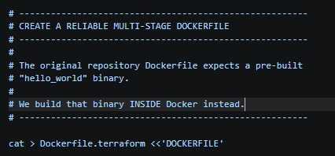
Stage 1 – Build
FROM golang:1.24-bookworm AS builder
This stage provides the Go environment required to compile the application.
The source code and Go dependencies are copied:
COPY go.mod go.sum ./
RUN go mod download

COPY . .
Then the application is compiled:
RUN CGO_ENABLED=0 GOOS=linux GOARCH=amd64 \
go build -buildvcs=false -o hello_world .
The result is a binary called:
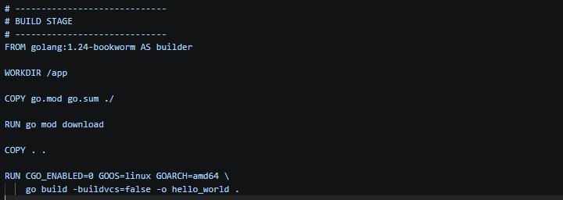
hello_world

Step 17: Create Final Docker Image The second stage uses:
FROM ghcr.io/vincetse/scratch:latest
Only the compiled application is copied:
COPY --from=builder /app/hello_world /hello_world
Then:
ENV GIN_MODE=release
sets the Gin framework to release mode.
The application exposes:
EXPOSE 8080
And starts using:
ENTRYPOINT ["/hello_world"]
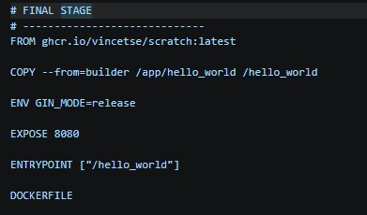
Why Multi-Stage Build?
The Go compiler and build dependencies are needed only during the build stage.
The final image contains only what is required to run the application.

Step 18: Create Docker Compose Configuration
The script creates: docker-compose.yml
The service is:
services: cb-app:
The image is built using: build: context: .
dockerfile: Dockerfile.terraform The container is named:
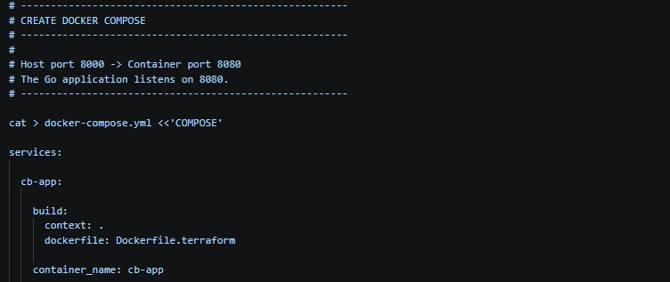
container_name: cb
-
app

Step 19: Configure Port Mapping

This is an important concept: ports: - "8000:8080"
The format is:
HOST PORT : CONTAINER PORT
Therefore:
EC2 Host
Port 8000
↓
Docker Container
Port 8080
The Go application listens on 8080 inside the container.
Docker makes it accessible on 8000 on the EC2 host.

Step 20: Configure Container Restart Policy restart: always
This tells Docker to automatically restart the container if it stops.
It also helps the application come back after Docker/host restarts.
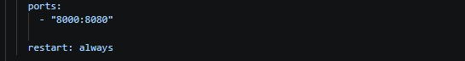

Step 21: Build and Start Application

The script executes:
docker compose up -d --build Meaning up
→ Creates and starts the service.
-d
→ Runs in detached/background mode.
--build
→ Builds the Docker image before starting the container.
So the application is automatically built and started.
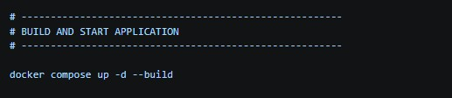

Step 22: Verify Docker Container

The script waits:
sleep 10 Then checks: docker compose ps
This verifies whether the container is running.
You can also check:
docker ps Expected architecture:
cb-app
|
└── Container Port 8080
↑
|
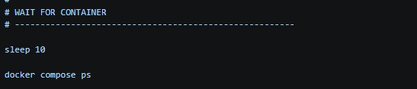

Host Port 8000

Step 23: Configure Nginx as Reverse Proxy

The script creates an Nginx configuration:
/etc/nginx/sites-available/cricbuzz
Nginx listens on: listen 8080; Then it forwards requests to: proxy_pass http://127.0.0.1:8000;
So the request flow becomes:
Browser
|
| :8080
↓
Nginx
|
| :8000
↓
Docker Container
|
| :8080
↓
Cricbuzz Application
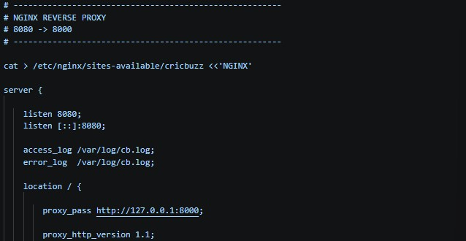

Step 24: Configure Proxy Headers

The configuration contains: proxy_set_header Host $host; proxy_set_header X-Real-IP $remote_addr; proxy_set_header X-Forwarded-For $proxy_add_x_forwarded_for; proxy_set_header X-Forwarded-Proto $scheme;
These headers pass useful information from the client request to the backend application.
For example:
- Original host
- Client IP
- Forwarded IP information
- HTTP/HTTPS protocol

Step 25: Enable Nginx Configuration The default Nginx configuration is removed:
rm -f /etc/nginx/sites-enabled/default Then the Cricbuzz configuration is enabled:
ln -sf \
/etc/nginx/sites-available/cricbuzz \
/etc/nginx/sites-enabled/cricbuzz
This creates a symbolic link from:
sites-available
↓
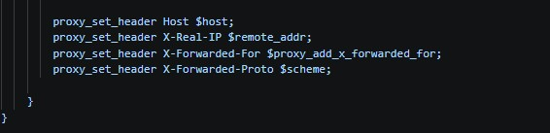
sites
-
enabled

Step 26: Test Nginx Configuration

Before restarting Nginx, the script runs:
nginx -t
This checks whether the Nginx configuration syntax is valid.
If the configuration is valid, Nginx is restarted:
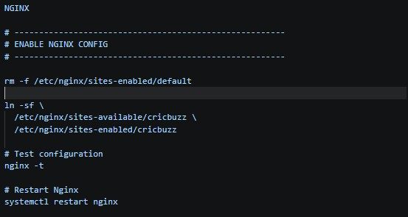
systemctl restart nginx

Step 27: Configure Application Logging

The script creates: touch /var/log/cb.log The file is given permissions: chmod 644 /var/log/cb.log Nginx is configured to write: access_log /var/log/cb.log; error_log /var/log/cb.log;
Therefore, application proxy access and error information can be stored in:
/var/log/cb.log
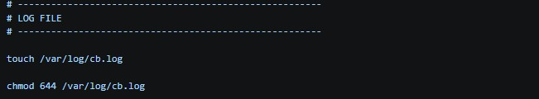

Step 28: Configure Logrotate

The script creates: /etc/logrotate.d/cb
It configures:
daily rotate 7 compress delaycompress
Meaning
- daily → Rotate logs every day.
- rotate 7 → Keep 7 rotated log files.
- compress → Compress old logs.
- delaycompress → Compress from the second-oldest rotation.
- missingok → Don't report an error if the log is missing.
- notifempty → Don't rotate an empty log.
This prevents log files from continuously consuming disk space.
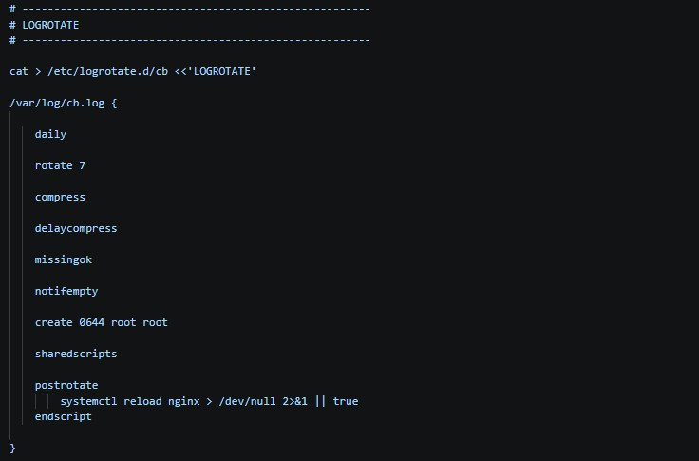

Step 29: Final Docker Verification

The script executes:
docker ps
This displays running containers.
It confirms that:
cb-app
is running.
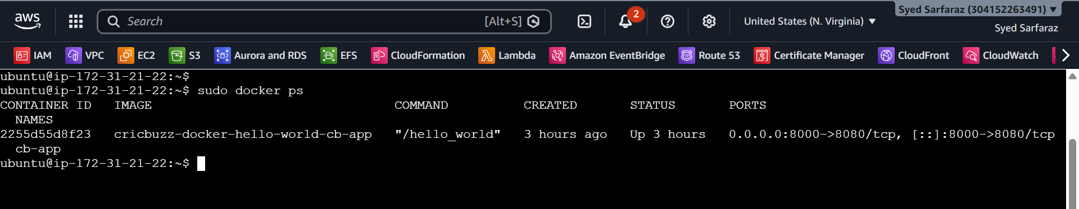

Step 30: Check Listening Ports
The script runs:
ss -lntp
This displays TCP ports currently listening on the server.
We expect to see services related to:
8080 → Nginx
8000 → Docker application

Step 31: Test Docker Application
The script tests: curl -f http://localhost:8000/ || true
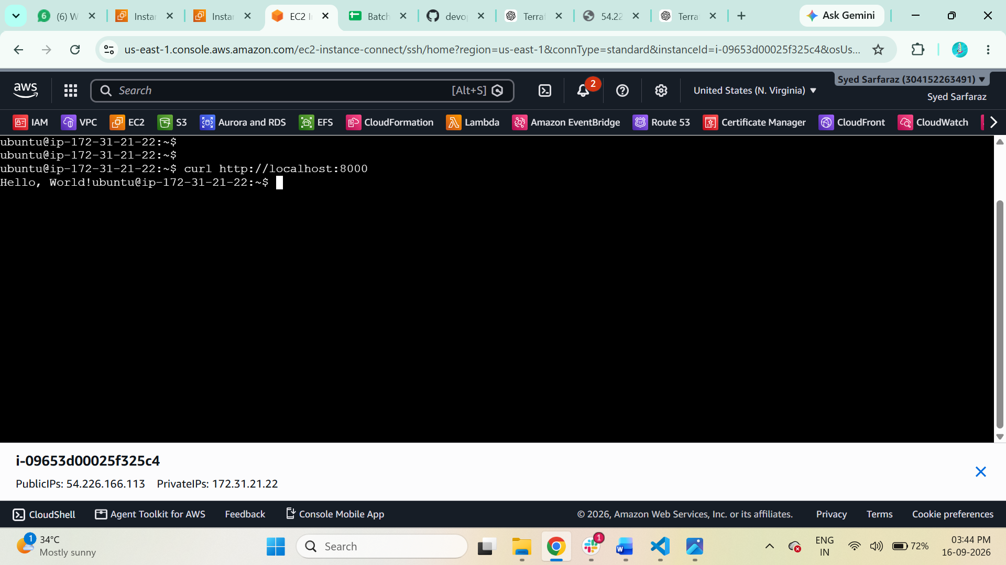
This verifies that the application is reachable through the Docker host port.
Flow: localhost:8000
↓
Docker
↓
Container:8080
↓
Cricbuzz application

Step 32: Test Nginx The script also tests: curl -f http://localhost:8080/ || true
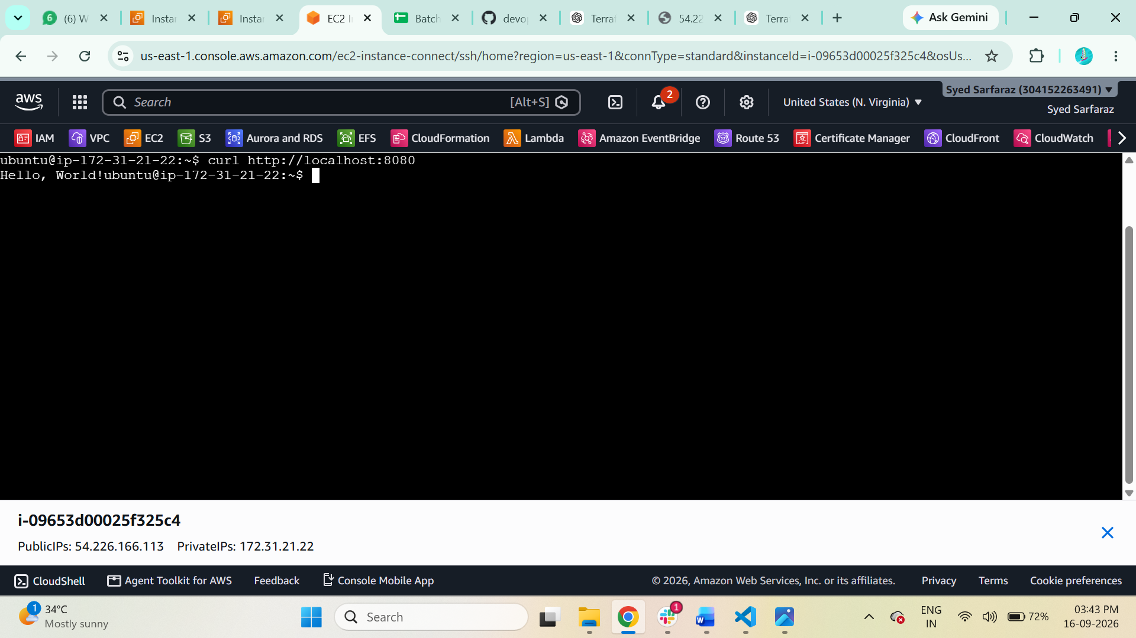
This verifies: localhost:8080
↓
Nginx
↓
localhost:8000
↓
Docker
↓
Application
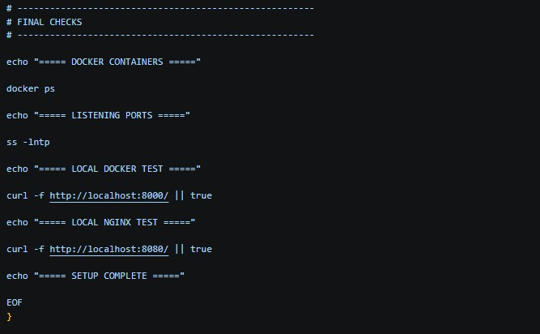

Step 33: Terraform Outputs

Finally, Terraform provides three outputs. Instance ID output "instance_id" { value = aws_instance.cricbuzz.id
}
This displays the EC2 instance ID.
Example: i-0123456789abcdef Public IP output "public_ip" { value = aws_instance.cricbuzz.public_ip
}
This displays the EC2 public IP. Application URL output "application_url" { value = "http://${aws_instance.cricbuzz.public_ip}:8080"
}
This gives the final application URL: http://<PUBLIC-IP>:8080
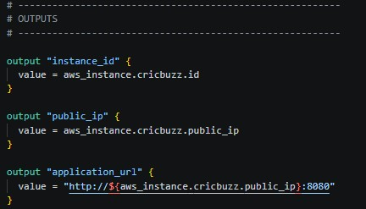

Step 34: Nginx status $ sudo systemctl status nginx
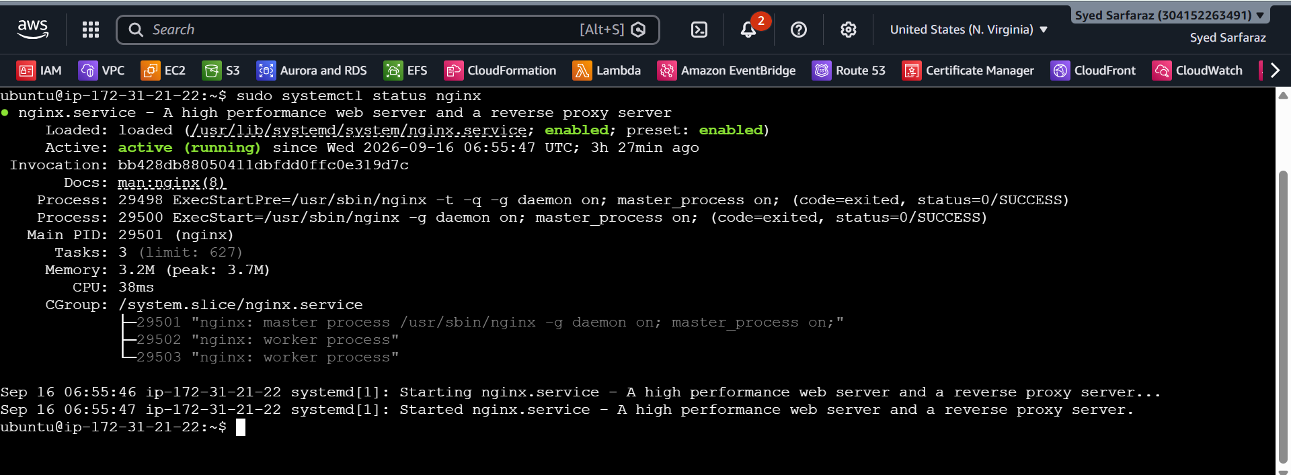

Step 34: Docker Container status $ docker ps
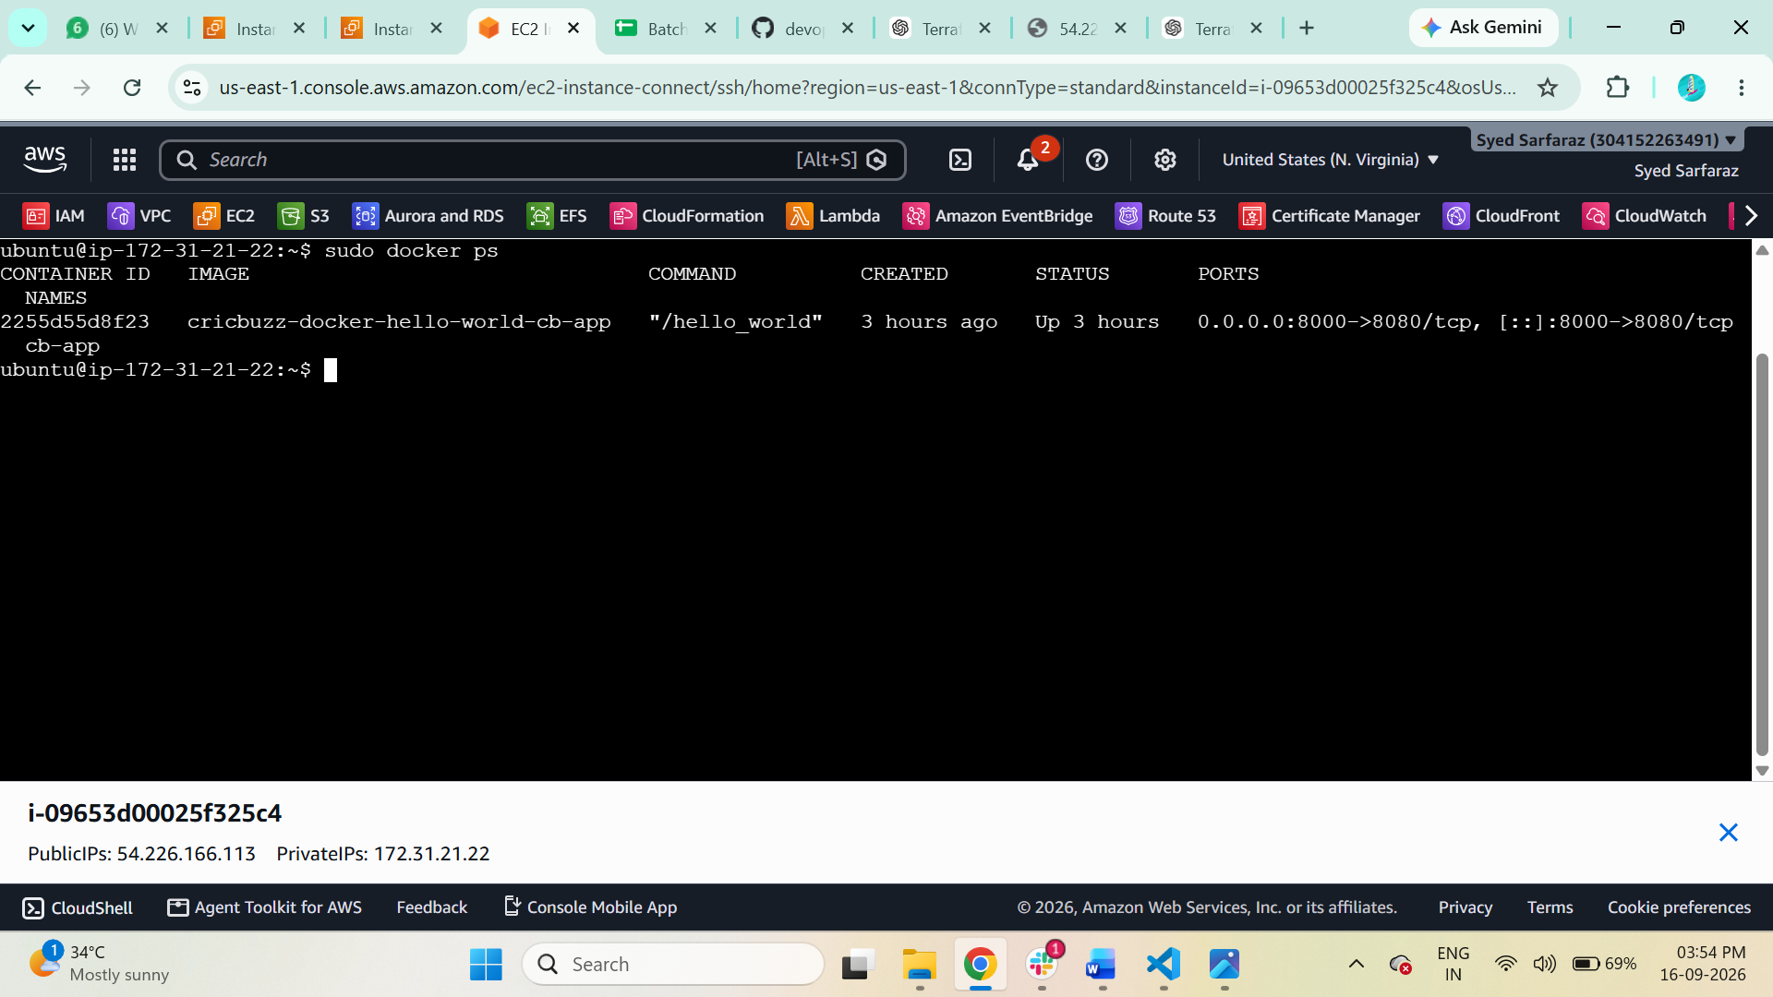

Step 35: Configure to Save the Logs in the location /var/log/cb.log
$ cat /var/log/cb.log
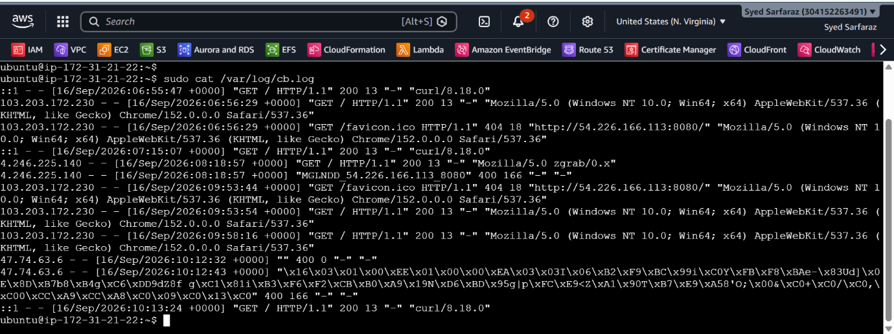

Step 36: Write the Log rotate configuration for the above file
$ cd /etc/logrotate.d && $ cat cd
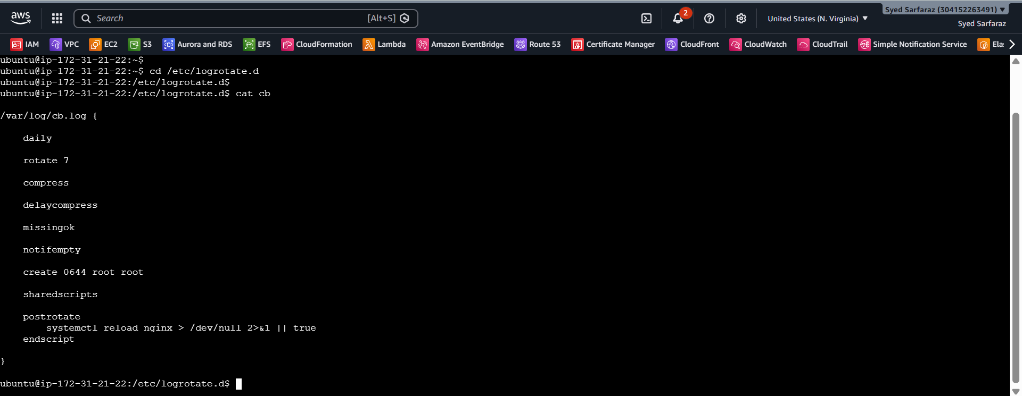

In this challenge I have Used 1 Script for this Entire Infrastructure

$ manin.tf

terraform {
required_providers {
aws = {
source = "hashicorp/aws"
version = "~> 6.0"
}
}
}

provider "aws" {
region = "us-east-1"
}

# ---------------------------------------------------------
# SECURITY GROUP
# ---------------------------------------------------------

resource "aws_security_group" "cricbuzz_sg" {
name = "cricbuzz-sg"
description = "Allow SSH and application traffic"
vpc_id = "vpc-03f33183207cea157"

# SSH
ingress {
description = "SSH"
from_port = 22
to_port = 22
protocol = "tcp"
cidr_blocks = ["0.0.0.0/0"]
}

# Nginx
ingress {
description = "Nginx 8080"
from_port = 8080
to_port = 8080
protocol = "tcp"
cidr_blocks = ["0.0.0.0/0"]
}

# Docker application
ingress {
description = "Docker 8000"
from_port = 8000
to_port = 8000
protocol = "tcp"
cidr_blocks = ["0.0.0.0/0"]
}

# Outbound
egress {
from_port = 0
to_port = 0
protocol = "-1"
cidr_blocks = ["0.0.0.0/0"]
}

tags = {
Name = "Cricbuzz-SG"
}
}

# ---------------------------------------------------------
# EC2 INSTANCE
# ---------------------------------------------------------

resource "aws_instance" "cricbuzz" {

ami = "ami-0b6d9d3d33ba97d99"
instance_type = "t3.micro"

key_name = "terraform"

subnet_id = "subnet-053c6d5909d65f5ba"

vpc_security_group_ids = [
aws_security_group.cricbuzz_sg.id
]

# -------------------------------------------------------
# USER DATA
# -------------------------------------------------------

user_data = <<-EOF
#!/bin/bash

set -euxo pipefail

# Save complete bootstrap log
exec > >(tee -a /var/log/user-data.log | logger -t user-data -s 2>/dev/console) 2>&1

echo "===== STARTING CRICBUZZ SETUP ====="

# -------------------------------------------------------
# SYSTEM UPDATE
# -------------------------------------------------------

apt-get update -y
apt-get upgrade -y

# -------------------------------------------------------
# INSTALL BASIC PACKAGES
# -------------------------------------------------------

apt-get install -y \
ca-certificates \
curl \
gnupg \
git \
nginx \
logrotate

# -------------------------------------------------------
# INSTALL DOCKER FROM OFFICIAL DOCKER REPOSITORY
# -------------------------------------------------------

install -m 0755 -d /etc/apt/keyrings

curl -fsSL https://download.docker.com/linux/ubuntu/gpg \
-o /etc/apt/keyrings/docker.asc

chmod a+r /etc/apt/keyrings/docker.asc

echo \
"deb [arch=$(dpkg --print-architecture) signed-by=/etc/apt/keyrings/docker.asc] https://download.docker.com/linux/ubuntu \
$(. /etc/os-release && echo "$VERSION_CODENAME") stable" \
> /etc/apt/sources.list.d/docker.list

apt-get update -y

apt-get install -y \
docker-ce \
docker-ce-cli \
containerd.io \
docker-buildx-plugin \
docker-compose-plugin

systemctl enable docker
systemctl start docker

systemctl enable nginx
systemctl start nginx

echo "===== DOCKER INSTALLED ====="

docker --version
docker compose version

# -------------------------------------------------------
# CLONE APPLICATION
# -------------------------------------------------------

rm -rf /opt/cricbuzz-docker-hello-world

git clone \
https://github.com/betawins/cricbuzz-docker-hello-world.git \
/opt/cricbuzz-docker-hello-world

cd /opt/cricbuzz-docker-hello-world

# -------------------------------------------------------
# CREATE A RELIABLE MULTI-STAGE DOCKERFILE
# -------------------------------------------------------
#
# The original repository Dockerfile expects a pre-built
# "hello_world" binary.
#
# We build that binary INSIDE Docker instead.
# -------------------------------------------------------

cat > Dockerfile.terraform <<'DOCKERFILE'

# -----------------------------
# BUILD STAGE
# -----------------------------
FROM golang:1.24-bookworm AS builder

WORKDIR /app

COPY go.mod go.sum ./

RUN go mod download

COPY . .

RUN CGO_ENABLED=0 GOOS=linux GOARCH=amd64 \
go build -buildvcs=false -o hello_world .

# -----------------------------
# FINAL STAGE
# -----------------------------
FROM ghcr.io/vincetse/scratch:latest

COPY --from=builder /app/hello_world /hello_world

ENV GIN_MODE=release

EXPOSE 8080

ENTRYPOINT ["/hello_world"]

DOCKERFILE

# -------------------------------------------------------
# CREATE DOCKER COMPOSE
# -------------------------------------------------------
#
# Host port 8000 -> Container port 8080
# The Go application listens on 8080.
# -------------------------------------------------------

cat > docker-compose.yml <<'COMPOSE'

services:

cb-app:

build:
context: .
dockerfile: Dockerfile.terraform

container_name: cb-app

ports:
- "8000:8080"

restart: always

COMPOSE

# -------------------------------------------------------
# BUILD AND START APPLICATION
# -------------------------------------------------------

docker compose up -d --build

# -------------------------------------------------------
# WAIT FOR CONTAINER
# -------------------------------------------------------

sleep 10

docker compose ps

# -------------------------------------------------------
# NGINX REVERSE PROXY
# 8080 -> 8000
# -------------------------------------------------------

cat > /etc/nginx/sites-available/cricbuzz <<'NGINX'

server {

listen 8080;
listen [::]:8080;

access_log /var/log/cb.log;
error_log /var/log/cb.log;

location / {

proxy_pass http://127.0.0.1:8000;

proxy_http_version 1.1;

proxy_set_header Host $host;
proxy_set_header X-Real-IP $remote_addr;
proxy_set_header X-Forwarded-For $proxy_add_x_forwarded_for;
proxy_set_header X-Forwarded-Proto $scheme;

}
}

NGINX

# -------------------------------------------------------
# ENABLE NGINX CONFIG
# -------------------------------------------------------

rm -f /etc/nginx/sites-enabled/default

ln -sf \
/etc/nginx/sites-available/cricbuzz \
/etc/nginx/sites-enabled/cricbuzz

# Test configuration
nginx -t

# Restart Nginx
systemctl restart nginx

# -------------------------------------------------------
# LOG FILE
# -------------------------------------------------------

touch /var/log/cb.log

chmod 644 /var/log/cb.log

# -------------------------------------------------------
# LOGROTATE
# -------------------------------------------------------

cat > /etc/logrotate.d/cb <<'LOGROTATE'

/var/log/cb.log {

daily

rotate 7

compress

delaycompress

missingok

notifempty

create 0644 root root

sharedscripts

postrotate
systemctl reload nginx > /dev/null 2>&1 || true
endscript

}

LOGROTATE

# -------------------------------------------------------
# FINAL CHECKS
# -------------------------------------------------------

echo "===== DOCKER CONTAINERS ====="

docker ps

echo "===== LISTENING PORTS ====="

ss -lntp

echo "===== LOCAL DOCKER TEST ====="

curl -f http://localhost:8000/ || true

echo "===== LOCAL NGINX TEST ====="

curl -f http://localhost:8080/ || true

echo "===== SETUP COMPLETE ====="

EOF
}

# ---------------------------------------------------------
# OUTPUTS
# ---------------------------------------------------------

output "instance_id" {
value = aws_instance.cricbuzz.id
}

output "public_ip" {
value = aws_instance.cricbuzz.public_ip
}

output "application_url" {
value = "http://${aws_instance.cricbuzz.public_ip}:8080"
}

